Road Maps: Around the World Adventure
Student Adventure Guide

Student Name:

Teacher Name/class period:

Adventure Title:

Journey # or letter:

Instructions:
- Save a copy of this document so that you can edit it.
- Type your name, teacher/class period, Adventure title and Journey letter in the spaces provided above.
- Use this graphic organizer to keep track of your completed work for Road Maps: Around the World Adventure.
- For each EXPLORATION task, simply copy and paste your answers directly into the chart. For each EXCURSION task, you may type your answers directly into the chart, or copy and paste a link to your work on another site.
- When you are finished with your journey, follow your teacher’s instruction to submit your completed Student Adventure Guide. Depending on the adventure you choose, you may or may not need to use all of the charts included in this Adventure Guide.

NOTE: If you paste a link to a Google Doc, Google Slides or Google Sheet, be sure to change the “sharing” settings so that your teacher can access your work.

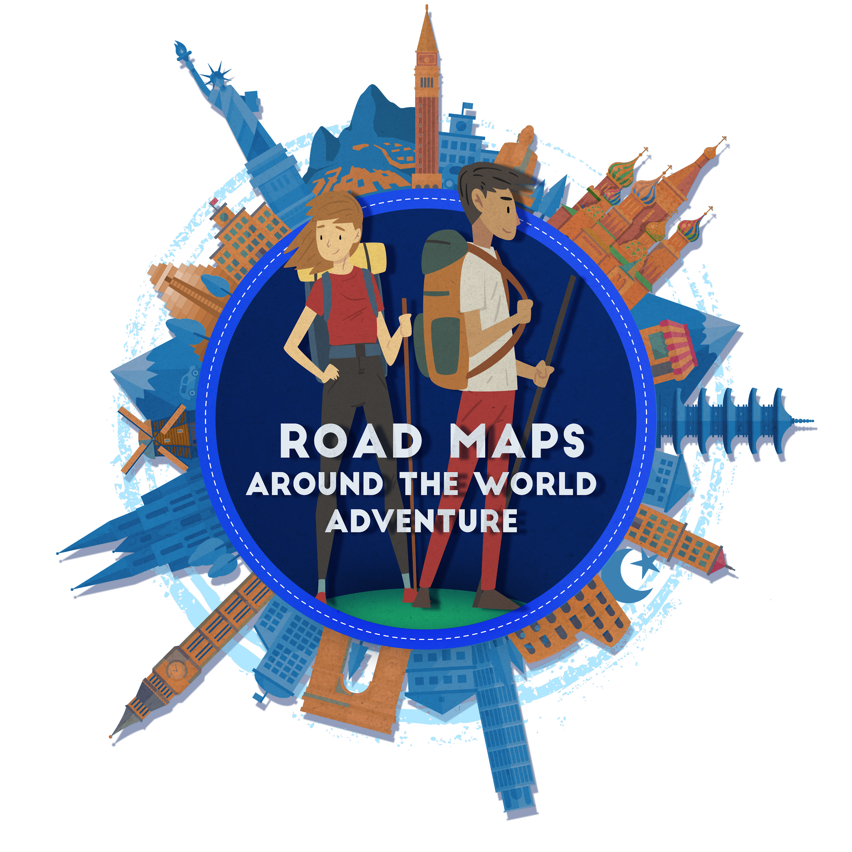

Destination Name (provide name of country/region):

Destination Location (use the map provided to describe where in the world this destination is located): ex. Morocco is a country located in Northern Africa

EXPLORATION
Copy and paste your EXPLORATION essay below:
EXCURSION
Copy and paste your completed EXCURSION task below. If you completed this task using an online app (Prezi, Slides, MovieMaker etc.) you may paste the link in the space provided.
Destination Name (provide name of country/region):

Destination Location (use the map provided to describe where in the world this destination is located): ex. Morocco is a country located in Northern Africa

EXPLORATION
Copy and paste your answers to each EXPLORATION question below:
EXCURSION
Copy and paste your completed EXCURSION task below. If you completed this task using an online app (Prezi, Google, MovieMaker etc.) you may paste the link in the space provided.
Destination Name (provide name of country/region):

Destination Location (use the map provided to describe where in the world this destination is located): ex. Morocco is a country located in Northern Africa

EXPLORATION
Copy and paste your EXPLORATION essay below:
EXCURSION
Copy and paste your completed EXCURSION task below. If you completed this task using an online app (Prezi, Slides, MovieMaker etc.) you may paste the link in the space provided.
Destination Name (provide name of country/region):

Destination Location (use the map provided to describe where in the world this destination is located): ex. Morocco is a country located in Northern Africa

EXPLORATION
Copy and paste your EXPLORATION essay below:
EXCURSION
Copy and paste your completed EXCURSION task below. If you completed this task using an online app (Prezi, Slides, MovieMaker etc.) you may paste the link in the space provided.

EXPLORATION
Copy and paste your EXPLORATION essay below:
Destination Name (provide name of country/region):

Destination Location (use the map provided to describe where in the world this destination is located): ex. Morocco is a country located in Northern Africa

EXCURSION
Copy and paste your completed EXCURSION task below. If you completed this task using an online app (Prezi, Slides, MovieMaker etc.) you may paste the link in the space provided.
Destination Name (provide name of country/region):

Destination Location (use the map provided to describe where in the world this destination is located): ex. Morocco is a country located in Northern Africa

EXPLORATION
Copy and paste your answers to each EXPLORATION question below:
1. | 2. | 3.
EXCURSION
Copy and paste your completed EXCURSION task below. If you completed this task using an online app (Prezi, Slides, MovieMaker etc.) you may paste the link in the space provided.
Destination Name (provide name of country/region):

Destination Location (use the map provided to describe where in the world this destination is located): ex. Morocco is a country located in Northern Africa

EXPLORATION
Copy and paste your answers to each EXPLORATION question below:
1. | 2. | 3.
EXCURSION
Copy and paste your completed EXCURSION task below. If you completed this task using an online app (Prezi, Slides, MovieMaker etc.) you may paste the link in the space provided.
Destination Name (provide name of country/region):

Destination Location (use the map provided to describe where in the world this destination is located): ex. Morocco is a country located in Northern Africa

EXPLORATION
Copy and paste your answers to each EXPLORATION question below:
1. | 2. | 3.
EXCURSION
Copy and paste your completed EXCURSION task below. If you completed this task using an online app (Prezi, Slides, MovieMaker etc.) you may paste the link in the space provided.
Destination Name (provide name of country/region):

Destination Location (use the map provided to describe where in the world this destination is located): ex. Morocco is a country located in Northern Africa

EXPLORATION
Copy and paste your answers to each EXPLORATION question below:
1. | 2. | 3.
EXCURSION
Copy and paste your completed EXCURSION task below. If you completed this task using an online app (Prezi, Slides, MovieMaker etc.) you may paste the link in the space provided.

