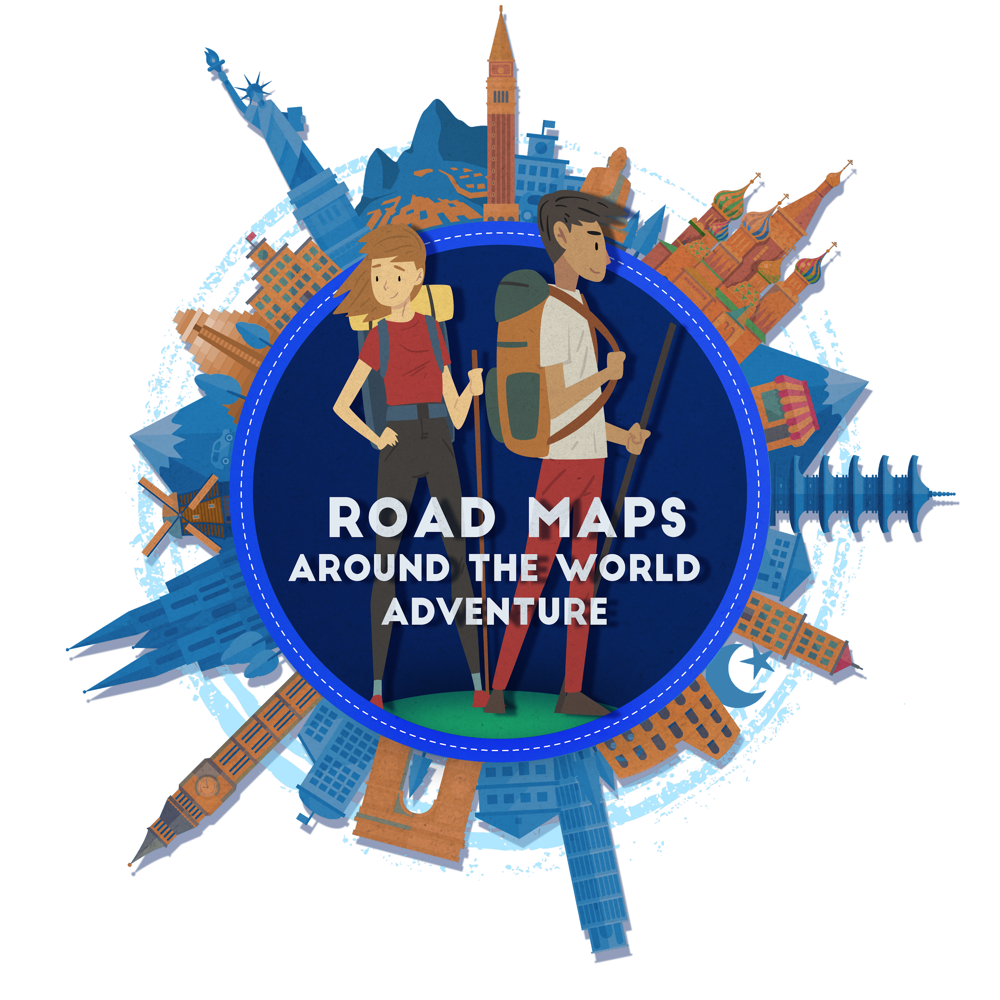

Teacher Introduction

Welcome to Road Maps: Around the World Adventure! Thank you for your interest in our digital journey around the world! We hope that these experiences help your students learn more about the world around them.

Click on the title of the adventure you want to learn more about, and it will link you to the correct location in this document.
Geography Adventure
Environmental Science Adventure
World History Adventure
World Religions Adventure

If you have questions about the resource or are having difficulty completing the activity, you may e-mail sbs-icc@email.arizona.edu for assistance.

Road Maps Adventures

Geography Adventure: The Geography Adventure makes up the original Road Maps activities and are suited for students in grades 5-12, or anyone interested in learning more about the world around them!
- 5 different journeys (A, B, C, D, E)
  - Each journey visits different destination cities, but the difficulty level is the same for each.
- Each journey consists of 3 different trips that will take students around the world. Within each trip, students will visit 3 different destinations. Students will have the option of continuing on to all 3 trips of the journey or may end the journey after trip 1 or 2.
- Depending on your individual students, you may want to assign them to complete an entire Journey or just part of one. You may also let students decide for themselves if they would like to finish with Trip 1 or complete all 3 Trips of their Journey.
- Includes Student Adventure Guide worksheet where students can record their work
- Includes extension activity for use with classes or large groups

Geography Adventure Destination Chart

 | Countries Visited | Journey A Destination | Journey B Destination | Journey C Destination | Journey D Destination | Journey E Destination
Trip 1 | Morocco | Casablanca | Tangier | Essaouira | Fes (Fez) | Marrakech
 | Peru | Iquitos | Lima | Sacred Valley | Machu Picchu | Cusco
 | Spain | Granada | Cueta | Madrid | Barcelona | Basque Country
Trip 2 | Bosnia-Herzegovina | Sarajevo | Mostar | Sarajevo | Sarajevo | Jajce
 | Oman | Salalah | Muscat | Nizwa | Wahiba Sands | Muscat
 | Guatemala | Antigua | Tikal | Lake Atitlan | Guatemala City | Chichicastenango
Trip 3 | Brazil | Brasilia | Salvador | Amazon Rainforest | Rio de Janeiro | Ouro Preto
 | Uzbekistan | Tashkent | Samarkand | Bukhara | Bukhara | Khiva
 | Jordan | Petra and Jaresh | Azraq Refugee Camp | Wadi Rum and Kerak | Dead Sea and Jordan River | Amman

Environmental Science Adventure: The Environmental Science Adventure is suited for middle and high school students and explores global environmental concerns, innovations and potential solutions.
- 3 different journeys (A, B, C)
- Each Environmental Science Journey is made up of 4 different trips, each focusing on one of the following topics:
  - Deforestation
  - Water scarcity
  - Climate change
  - Alternative energy sources.
- Includes Student Adventure Guide worksheet where students can record their work

Environmental Science Adventure Destination Chart

Environmental Science journey components | Journey A  destinations | Journey B  destinations | Journey C  destinations
Part 1: deforestation | Indonesia | Amazon Rainforest | S.E. Asia
Part 3: water scarcity | Israel | Latin America | Singapore
Part 3: climate change | Mexico | Tunisia | Guatemala
Part 4: alternative energy | Costa Rica | Kenya | Iceland

World History Adventure: The World History Adventure is designed for middle and high school students and aligns well with AP U.S. History standards.
- 3 separate pieces: Ancient World, Medieval World & Modern World
  - Ancient World: 5 destinations
  - Medieval World: 5 destinations
  - Modern World: 5 destinations
- Depending on the grade level/subject you teach, you may wish to assign one piece at a time (ex. only Ancient World) or you may choose to assign all 3 adventures consecutively.
- Includes Student Adventure Guide worksheet where students can record their work.

World History Adventure Destination Charts

Time Period | Journey A destinations
Ancient | Egypt | China | Central America  (Zapotec & Toltecs) | Rome | Greece
Medieval
Modern

Time Period | Journey B destinations
Ancient | Mesopotamia | India | Central America  (Olmec/Maya) | Rome | Greece
Medieval
Modern

Time Period | Journey C destinations
Ancient | Persia/Iran | Pakistan  (Ghandara) | Central America  (Aztecs) | Rome | Greece
Medieval
Modern

Assigning Journeys to your Students

- You may choose to let students decide which journey they would like to take or you may assign one (or more) to them. It may be useful to assign journeys so that students can share what they learned with one another about their different destinations once they have completed the assignment (Jigsaw activity)
- Students will not know ahead of time which cities and countries they will visit during their journey, but this information is provided in the teacher’s guide.
- To begin, students will simply click on the link of the Journey that they are assigned (on the Website) and follow the prompts to continue.
- Road Maps does not save copies of your students’ work for you to access. Therefore, if you would like to collect copies of your students completed tasks for grading purposes, make sure that you instruct your students to save their completed tasks on their Student Adventure Guide so that they may then save/email their work to you in one place.

Adventure Links

Listed below are the links included in each Journey if you would like to review them prior to assigning this activity. Note that some links are repeated in several Journeys.

Geography Adventure
Journey A:
https://www.youtube.com/watch?v=4et8JZefbJQ
https://www.youtube.com/watch?v=AJNUWll8yyw
https://www.youtube.com/watch?v=n2T-_6ssvAU
https://www.youtube.com/watch?v=0IFNaep7MW8
https://cmes.arizona.edu/sites/cmes.arizona.edu/files/Bosnia%20-%20understanding%20ethnic%20identites.pdf
https://www.youtube.com/watch?v=7TnWps3JnHs
https://www.youtube.com/watch?v=nhGSGXFAiMY
https://www.youtube.com/watch?v=oA53ZanVNgc
https://www.youtube.com/watch?v=pnCPHo7OAOk
https://www.youtube.com/watch?v=MvFor6cumHM
https://www.youtube.com/watch?v=SZ5JjLdzQ1o
https://www.youtube.com/watch?v=TU_XaM_EHAY

Journey B:
https://www.youtube.com/watch?v=bpKJSB4HUfE
https://www.youtube.com/watch?v=PaGpt5y8OMI
https://www.youtube.com/watch?v=ZlnlzE_eeks
https://www.youtube.com/watch?v=yEkQdE-bn7A
https://www.youtube.com/watch?v=VbApdFxiUCY
https://cmes.arizona.edu/sites/cmes.arizona.edu/files/Bosnia%20-%20understanding%20ethnic%20identites.pdf
https://www.youtube.com/watch?v=o5NkJvrdwkk
https://www.youtube.com/watch?v=vrgn9NQ2
https://www.youtube.com/watch?v=lgsQndSyfHg
https://www.youtube.com/watch?v=-2sUCcaPkAE
https://www.youtube.com/watch?v=IMJmFkH7cko
https://www.youtube.com/watch?v=1feAEm1EnSI
https://www.youtube.com/watch?v=eapHEWsMUDU
https://www.youtube.com/watch?v=hhgm3mE-cTg

Journey C:
https://www.youtube.com/watch?v=YXi8-KmJjsY
https://www.youtube.com/watch?v=YNm5mihOxww
https://www.youtube.com/watch?v=gBNApw42JYU
https://www.youtube.com/watch?v=0IFNaep7MW8
https://cmes.arizona.edu/sites/cmes.arizona.edu/files/Bosnia%20-%20understanding%20ethnic%20identites.pdf
https://www.youtube.com/watch?v=7l7kHsunpvU
https://www.youtube.com/watch?v=GrOy1AtOn7o
https://www.youtube.com/watch?v=oela7cDoyzY
https://www.youtube.com/watch?v=BlCxQ4Ci1qg
https://www.youtube.com/watch?v=eSCNpg2vrPE
https://www.youtube.com/watch?v=s3ecMAGBb4I

Journey D:
https://www.youtube.com/watch?v=zrxM9A260jg
https://www.youtube.com/watch?v=cnMa-Sm9H4k
https://www.youtube.com/watch?v=Zk9J5xnTVMA
https://www.youtube.com/watch?v=Y9qZf_imVTs
https://www.youtube.com/watch?v=0IFNaep7MW8
https://cmes.arizona.edu/sites/cmes.arizona.edu/files/Bosnia%20-%20understanding%20ethnic%20identites.pdf
https://www.youtube.com/watch?v=h0QVlH_GeCM
https://www.youtube.com/watch?v=f_GedOj9brA
https://www.youtube.com/watch?v=ieWNzZPfZzk
https://www.youtube.com/watch?v=BlCxQ4Ci1qg
https://www.youtube.com/watch?v=LaiqHi4thg0
https://www.youtube.com/watch?v=UFE4_hCe0OU

Journey E:
https://www.youtube.com/watch?v=YCdP2z0NjhI
https://www.youtube.com/watch?v=OxKr5uievd4
https://www.youtube.com/watch?v=hXDGt97eNxA
https://www.youtube.com/watch?v=JYwUUDdYi9I
https://www.youtube.com/watch?v=XPMCaE8unwg
https://cmes.arizona.edu/sites/cmes.arizona.edu/files/Bosnia%20-%20understanding%20ethnic%20identites.pdf
https://www.worldometers.info/img/maps/bosnia_road_map.gif
https://www.youtube.com/watch?v=o5NkJvrdwkk
https://www.youtube.com/watch?v=uJIYq3ZOGLk
https://www.youtube.com/watch?v=WU9n61VYgEc
https://www.youtube.com/watch?v=KrL6B40wBok
https://www.youtube.com/watch?v=ngBx0fyukXg

